1100_CPP Enrollment initiated by EV for Residential Combo Customer
Contract No. 4017167954
Material No. 88000105
Serial No. 29101109
Equipment No. 100005155094
Contract Account. 100059434942
Functional Location. 6002276639
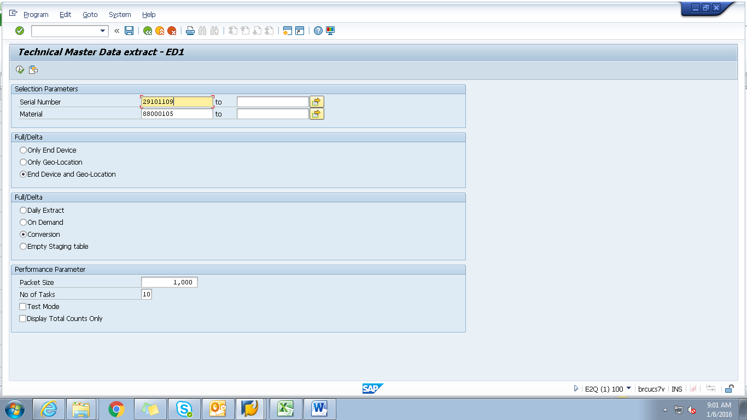

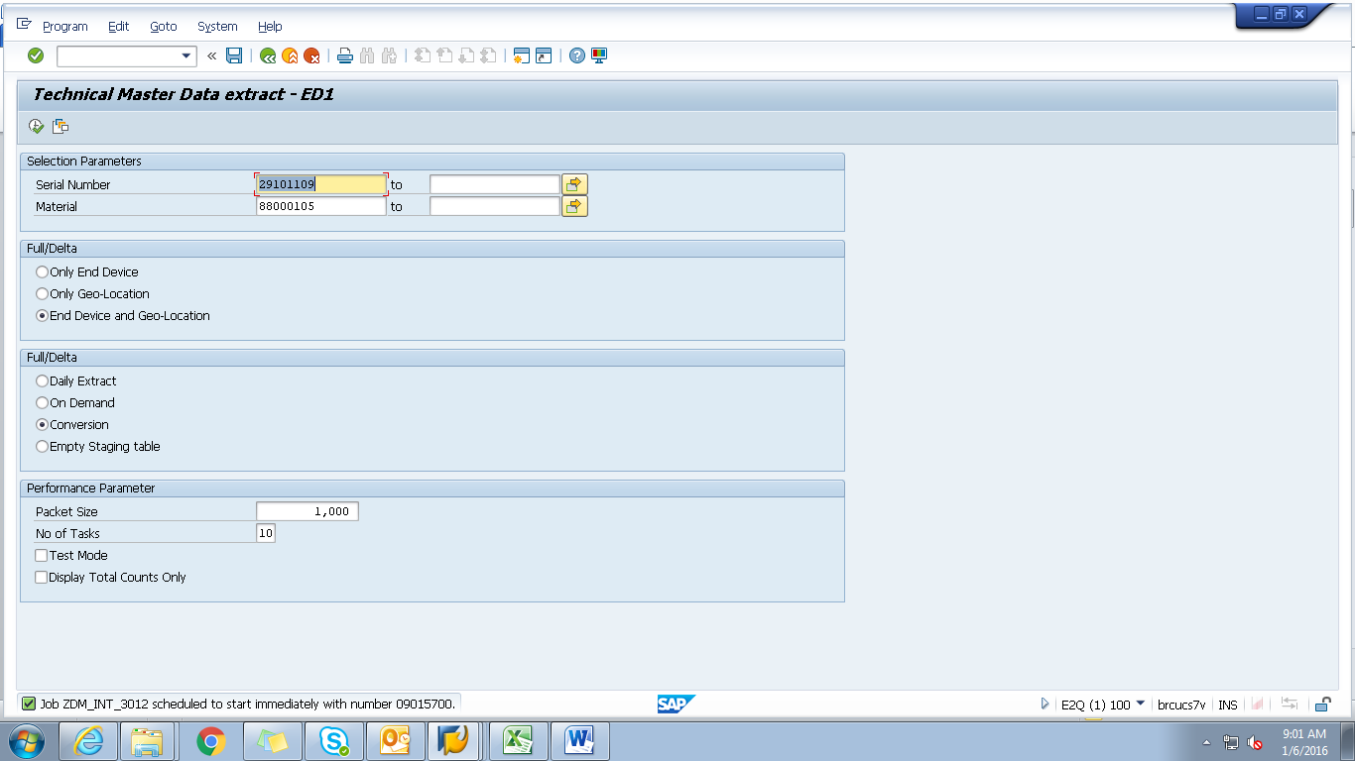
Spool
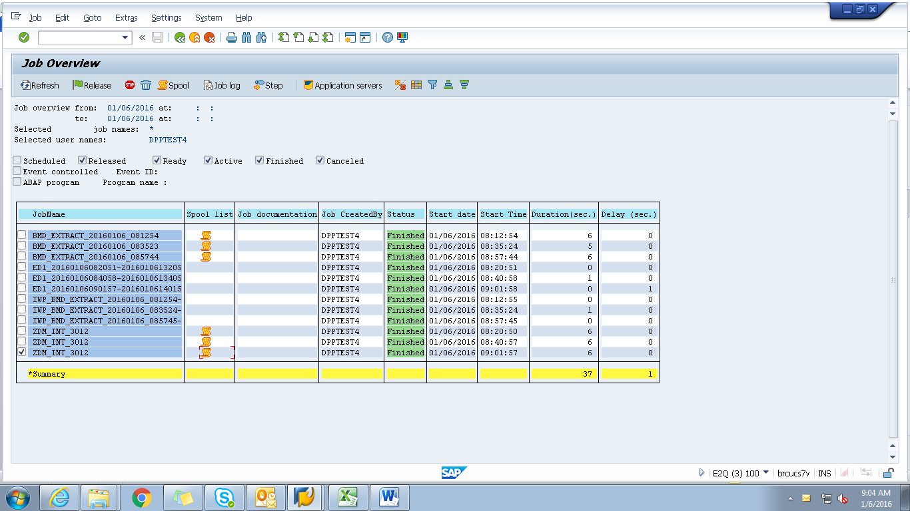

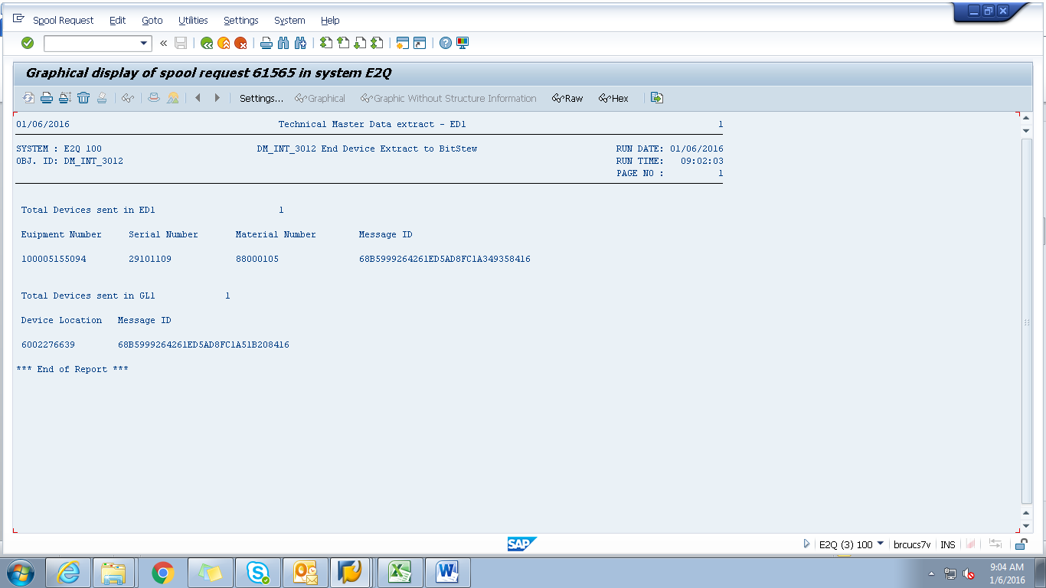
Payload
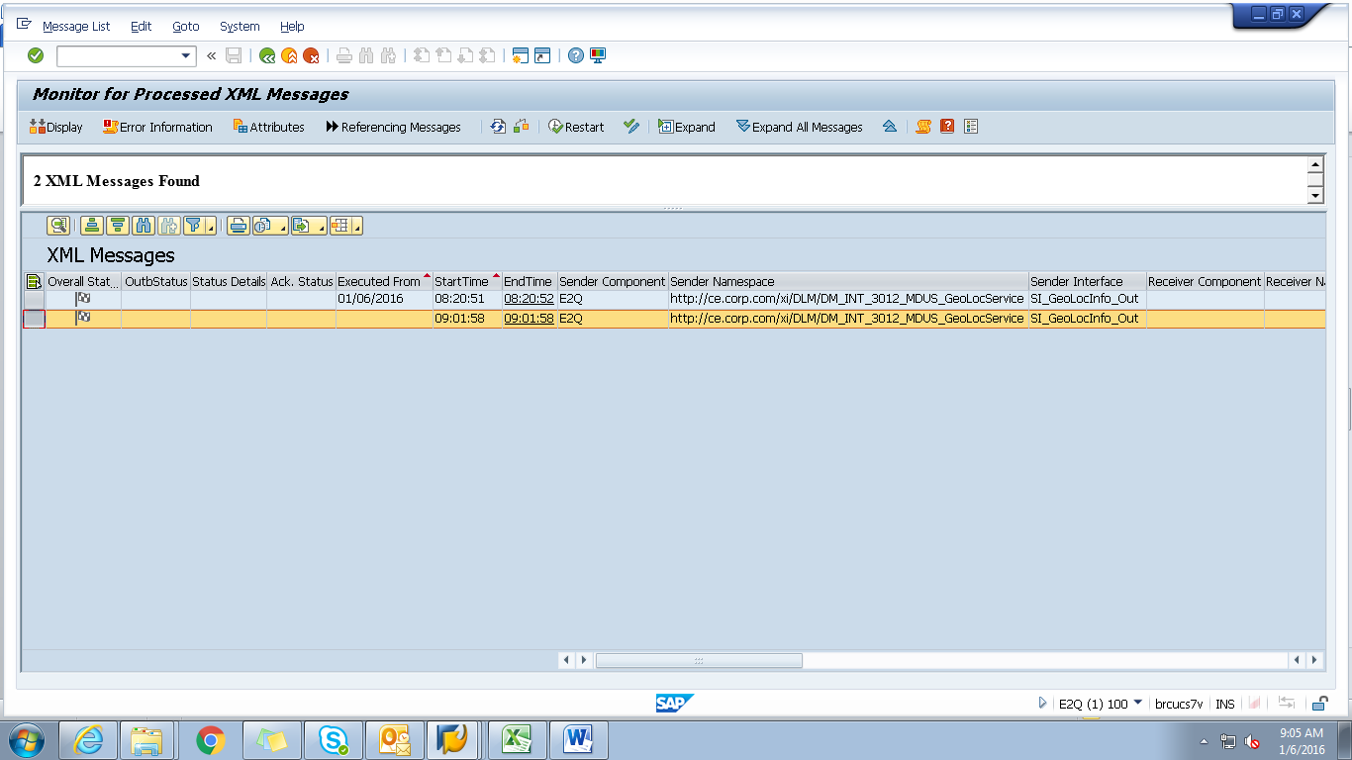

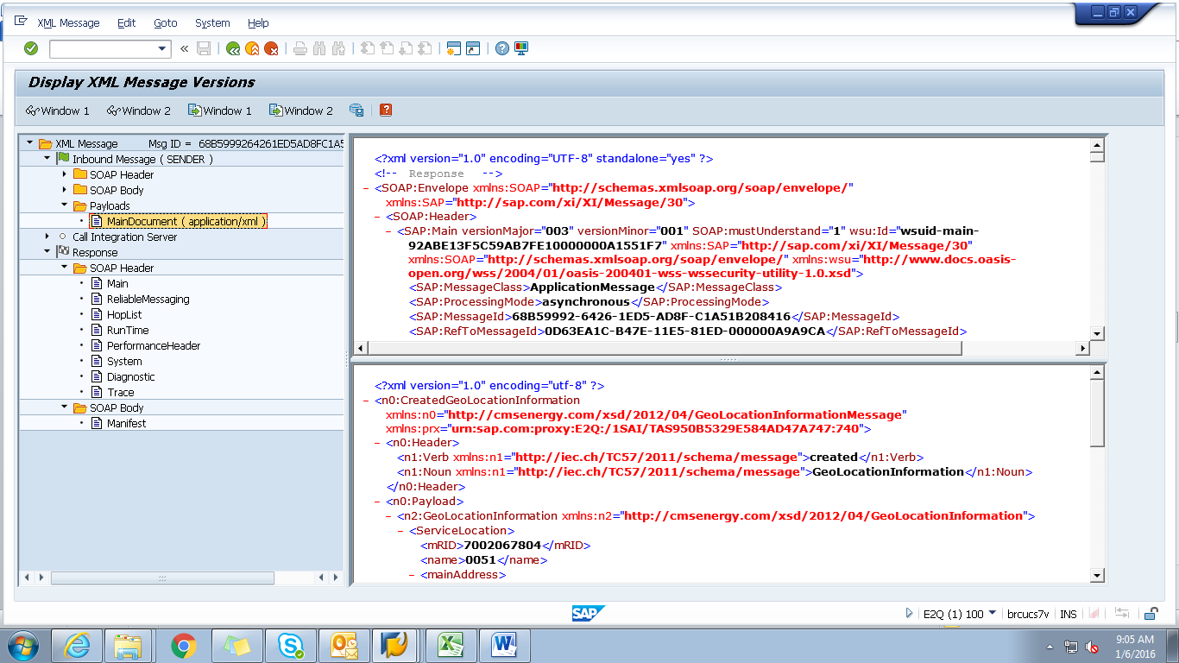

<?xml version="1.0" encoding="utf-8" ?>
- <n0:CreatedGeoLocationInformation xmlns:n0="http://cmsenergy.com/xsd/2012/04/GeoLocationInformationMessage" xmlns:prx="urn:sap.com:proxy:E2Q:/1SAI/TAS950B5329E584AD47A747:740">
- <n0:Header>
<n1:Verb xmlns:n1="http://iec.ch/TC57/2011/schema/message">created</n1:Verb>
<n1:Noun xmlns:n1="http://iec.ch/TC57/2011/schema/message">GeoLocationInformation</n1:Noun>
</n0:Header>
- <n0:Payload>
- <n2:GeoLocationInformation xmlns:n2="http://cmsenergy.com/xsd/2012/04/GeoLocationInformation">
- <ServiceLocation>
<mRID>7002067804</mRID>
<name>0051</name>
- <mainAddress>
- <streetDetail>
<addressGeneral>15240 SILVER PKWY</addressGeneral>
<suiteNumber>#305</suiteNumber>
</streetDetail>
- <townDetail>
<code>48430-3485</code>
<name>FENTON</name>
<stateOrProvince>MI</stateOrProvince>
</townDetail>
</mainAddress>
- <UsagePoints>
<mRID>6002276639</mRID>
<name>OUT RIGHT</name>
- <EndDevices>
<mRID>CA-25-05562742-0144</mRID>
<type>T</type>
</EndDevices>
- <PositionPoint>
<xPosition>-86.276639</xPosition>
<yPosition>43.276639</yPosition>
</PositionPoint>
</UsagePoints>
</ServiceLocation>
</n2:GeoLocationInformation>
</n0:Payload>
</n0:CreatedGeoLocationInformation>

